It is with great excitement that we invite you to participate in a very special event. The Eastern European Congress of Ohio (EECOH) is sponsoring their Annual Eastern European Month Dinner on Saturday, April 20, 2024, at Cretan Banquet Center, 3853 West 168th Street, Cleveland, OH 44111. The celebration will start at 6 pm.

The Eastern European Congress of Ohio (www.eecoh.org) is a 501 (c) 3 nonprofit charity established to unite over 1 million Ohio residents whose ancestry and heritage are from Eastern Europe. We foster discussions and events through bipartisanship to advance Ohio’s Eastern European agenda.

Please consider supporting our celebration by donating gift certificates, merchandise or services valued over $200.00 for our Silent Auction. Ideal items we are looking to showcase at our Eastern European Month celebration are electronics, travel packages, authentic autographed memorabilia, a personal chef dinner party and lottery gift baskets. Your silent auction donation will receive excellent exposure throughout Ohio and on our website. Your company name and logo will be listed in our dinner celebration program. In addition, your donation is tax deductible, upon request we would be happy to provide our tax ID number.

For your item to be included in our dinner celebration program, we must receive your donation information by Monday, April 1, 2024. This information can be emailed to eecofohio@gmail.com or can be mailed at: 1500 Seneca Blvd, Suite B201, Broadview Heights, OH 44147.

If you have any questions, please feel free to call 330-727-2790 or 937-602-1240.

Thank you in advance for your support. Together we can make a difference!

Sincerely,

Laurel A. Tombazzi, Chairperson
Eastern European Congress of Ohio

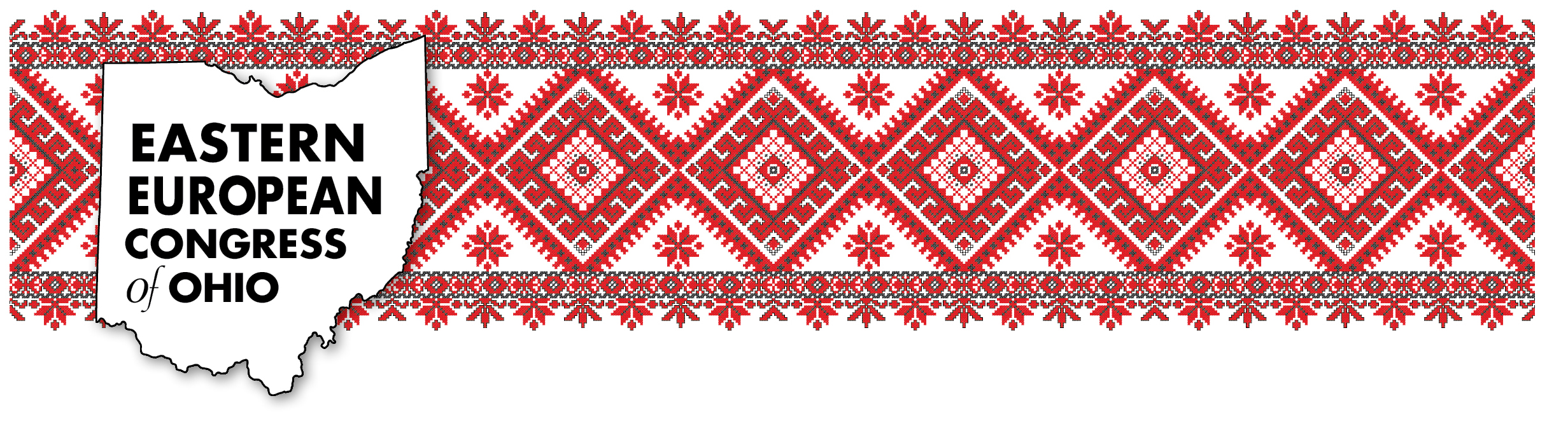
David Boston, Board Member
Eastern European Congress of Ohio

